**UNIVERSITY OF COMPUTER STUDIES ( MONYWA )**

**FAMOUS PALACES IN MYANMAR**

**(FPM SYSTEM)**

**MARCH , 2019 SECOND YEAR ( A ) : GROUP I**

**SUPERVISOR:DAW SOE SOE NWE**

**MEMBER LIST**

**NO. NAME ROLLNO.**

1. **Mg Aung Min Soe(Leader) 2CS-26**
2. **Mg Zayar Win Htet 2CS-48**
3. **Ma Htay Htay Maw 2CS-3**
4. **Ma Yamohn Zin Kyaw 2CS-25**
5. **Ma Moe Thae Oo 2CS-33**
6. **Ma San San Maw 2CS-32**
7. **Ma May Khaing Soe 2CS-14**
8. **Ma Chan Myae Zaw 2CS-10**
9. **Ma Thwe Thwe Htoo Swe 2CS-30**
10. **Ma Saw Wai Hnin 2CS-24**

CONTENTS

1 . ABSTRACT

2 . OBJECTIVES

3 . ENTITY RELATIONSHIP DIAGRAN

4 . DATA DICTIONARY

5 . DATABASE DESIGN

6 . QUERY

7 . CONCLUSION

**1.ABSTRACT**

Travelling is a large growing business across all countries . But this project intends to help the travellers to know famous place in Myanmar . This project distinguishes into region and state . So , both tourists and travellers in Myanmar can travel easily. This benefit will get by using this system.

**2 . Objective**

* To know where famous places what things in Myanmar
* To get easily information about famous places in Myanmar
* To go if you should know Region and State
* To know Region and State show this system
* To aim for Myanmar citizen and other aliens
* To know immediately what famous in a place

**3 . ENTITY RELATIONSHIP DIAGRAM**

FMOUNTAIN

FMNO

MNAME

CNO

LOCATION

HIGHT

FLAKE

FLNO

FNAME

CNO

LOCATION

AREA

STATE

SNO

SNAME

REGION

RNO

RNAME

CITY

CNO

RNO

SNO

CNAME

FPAGODA

FPNO

FPNAME

CNO

LOCATION

HEIGHT

FOUNDER

START_YEAR

COMPLETE_YEAR

FBEACH

FBNO

FBNAME

CNO

LOCATION

FWATERFALL

FWNO

WNAME

CNO

LOCATION

HEIGHT

WATER_COLOR

FPALACE

FPLNO

PLNAME

CNO

LOCATION

FOUNDER

START_YEAR

COMPLETE_YEAR

4 . DATA DICTIONARY

|  |  |  |  |  |  |
| --- | --- | --- | --- | --- | --- |
| Table | Attribute | Type | Required | PK/FK | FK Reference table |
| REGIN | RNO | VARCHAR(5) | YES | PK |  |
| RNAME | VARCHAR(20) | YES |  |  |
| STATE | SNO | VARCHAR(5) | YES | PK |  |
| SNAME | VARCHAR(20) | YES |  |  |
| CITY | CNO | VARCHAR(5) | YES | PK |  |
| RNO | VARCHAR(5) | YES |  | REGIN |
| SNO | VARCHAR(5) | YES |  | STATE |
| CNAME | VARCHAR(50) | YES |  |  |
| FPAGODA | FPNO | VARCHAR(5) | YES | PK |  |
| FPNAME | VARCHAR(50) | YES |  |  |
| CNO | VARCHAR(5) | YES |  | CITY |
| LOCATION | VARCHAR(20) | YES |  |  |
| HEIGHT | VARCHAR(10) | NO |  |  |
| FOUNDER | VARCHAR(20) | NO |  |  |
| START_YEAR | DECIMAL(20,0) | NO |  |  |
| COMPLETE_YEAR | DECIMAL(20,0) | NO |  |  |
| FWATERFALL | FWNO | VARCHAR(5) | YES | PK |  |
| WNAME | VARCHAR(20) | YES |  |  |
| CNO | VARCHAR(5) | YES |  | CITY |
| LOCATION | VARCHAR(20) | YES |  |  |
| HEIGHT | VARCHAR(20) | NO |  |  |
| WATER_COLOR | VARCHAR(30) | NO |  |  |
| FBEACH | FBNO | VARCHAR(5) | YES | PK |  |
| FBNAME | VARCHAR(30) | YES |  |  |
| CNO | VARCHAR(5) | YES |  |  |
| FBEACH | LOCATION | VARCHAR(20) | NO |  |  |
| FPALACE | FPLNO | VARCHAR(5) | YES | PK |  |
| PLNAME | VARCHAR(30) | YES |  |  |
| CNO | VARCHAR(5) | YES |  | CITY |
| LOACTION | VARCHAR(20) | YES |  |  |
| FOUNDER | VARCHAR(20) | NO |  |  |
| START_YEAR | VARCHAR(10) | NO |  |  |
| COMPLETE_YEAR | VARCHAR(10) | NO |  |  |
| FLAKE | FLN0 | VARCHAR(5) | YES | PK |  |
| FLNAME | VARCHAR(30) | YES |  |  |
| CNO | VARCHAR(5) | YES |  | CITY |
| LOACTION | VARCHAR(20) | YES |  |  |
| AREA | VARCHAR(30) | NO |  |  |
| FMOUNTAIN | FMNO | VARCHAR(5) | YES | PK |  |
| MNAME | VARCHAR(20) | YES |  |  |
| CNO | VARCHAR(5) | YES |  | CITY |
| LOCATION | VARCHAR(30) | YES |  |  |
| HIGHT | VARCHAR(10) | NO |  |  |

5 .DATABASE DESIGN

**STATE**

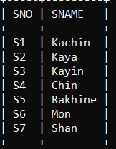

REGION

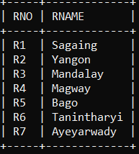

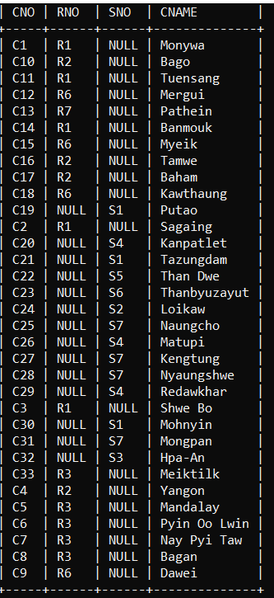**CITY**

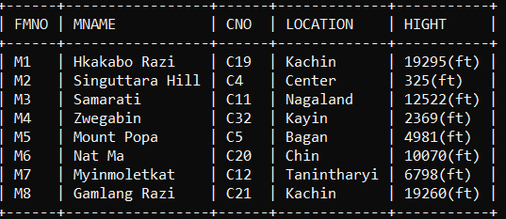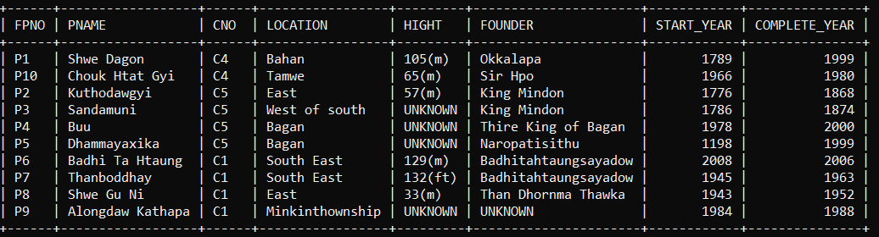

FMOUNTAIN

FPAGODA

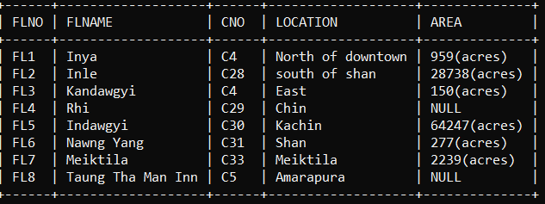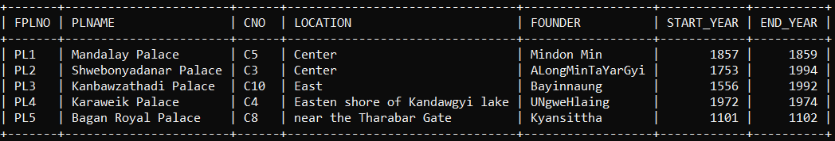

FLAKE

FPALACE

FPALACE

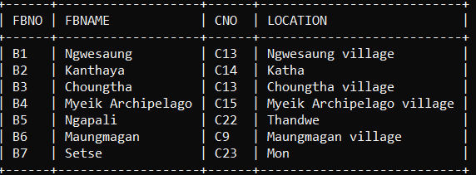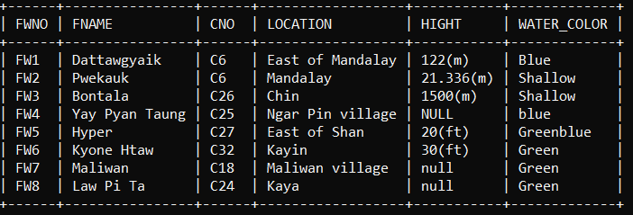

FBEACH

FWATERFALL

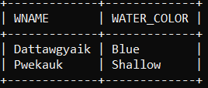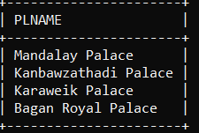

2.Get waterfall’s color and name for waterfall who supply region equal R3.

SELECT FWATERFALL.WATER_COLOR,FWATERFALL.WNAME FROM FWATERFALL WHERE FWATER.CNO IN (SELECT CITY.RNO IN(SELECT REGION.RNO FROM REGION WHERE REGION.RNO=’R3’;

6 . QUERY

1.Retrieve all information of palace whose name is second with ‘a’.

SELECT PLNAME FROM FPALACE WHERE PLNAME LIKE ‘_A%’;

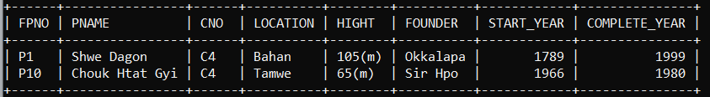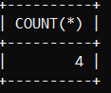

4.Get pagoda name for pagoda who supply region equal R2.

SELECT * FROM PAGODA WHERE FPAGODA.CNO IN (SELECT CITY.CNO FROM CITY WHERE CITY.CNO IN (SELECT REGION.RNO FROM REGION WHERE REGION.RNO = ‘R2’;

2’

3.Get the total number of pagoda where city number is ‘C4’.

SELECT COUNT(*) FROM FPAGODA WHERE CNO = ‘C4’;

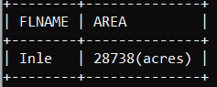

5.Get lake’s name and area where city is Nyaungshwe.

SELECT FLAKE.FNAME , FLAKE.AREA FROM FLAKE WHERE FLAKE WHERE FLAKE.CNO IN (SELECT CITY.CNO FROM CITY WHERE CITY.CNO = ‘C28’;

**8 . Conclusion**

This system will help for unknown people where places have what things. That is pagodas , waterfall, mountain and so on…Today people want to go famous place but they are not know where .That this system aim for travelling people . We must hope this system is very useful for traveller and other aliens.